LAB 321Assignment | Type: | LongAssignment
 | Code: | J3.L.P0049
 | LOC: | 100
 | Slot(s): | 5

Title: Build large calendar

Background

Program Specifications
Program a web site display list of days as calendar
Features:
This website contains following main functions
- Function 1: Display date
  - Display date as a calendar
  - Sunday on red
  - Current day on Green
  - Other on Blue
  - << to go to previous month
  - >> to go to next month
  - == to go to current month

Database description
- Image URL
- Image description

Expectation of User interface:

PIC 1 : Calendar

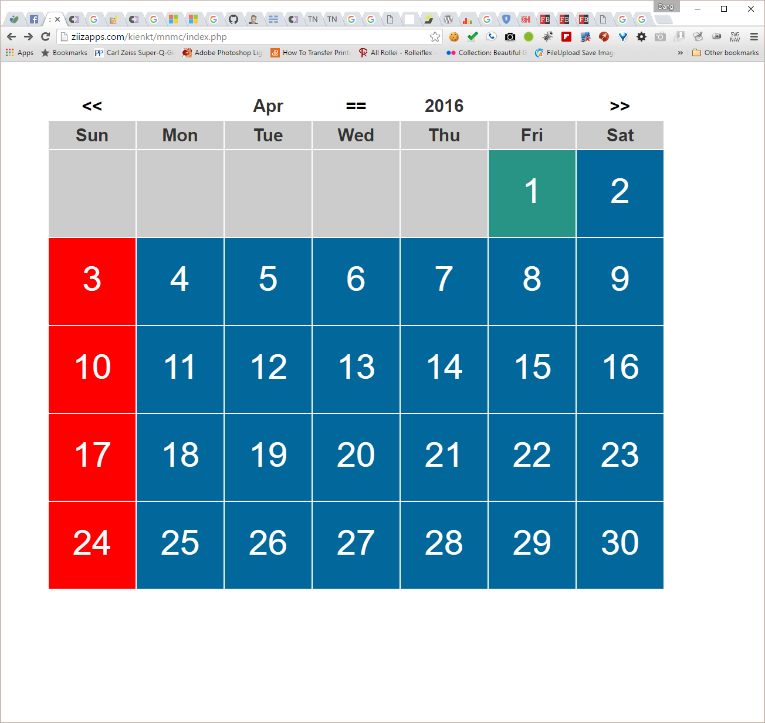

Guidelines
- Step 1 : Create web layout
- Step 2 : Create prototype
- Step 3 : Code & Test

